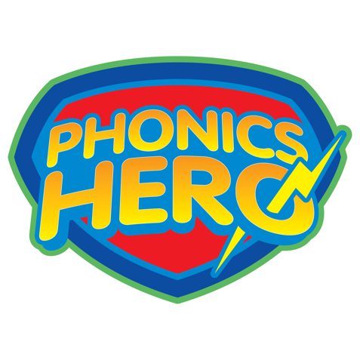
Dear Parent & Carers,
In school we teach early reading and spelling using phonics. We have secured a free trial of Phonics Hero for our students to help them practise what they are learning at school.
Your child’s Phonics Hero account will give them access to over 850 fun phonics games which will practice the sounds, blending to read and segmenting to spell.
Please find your child’s unique login information attached.

To login on a computer:
Go to www.phonicshero.com. Phonics Hero works best on the Chrome internet browser.
To login on an iPad or Android tablet:
Go to the App Store type in “Phonics Hero” and download the free app. Your operating system will need to be at least iOS 13 or Android 9.
Some tips:
- The first time your child plays be on hand to guide them through. Talk about the storyline (rescuing superheroes!) and explore the account with your child.
- We recommend a “little and often” approach; 5-10 minutes practice a day, 3 or 4 times a week is a good target.
- If you child struggles with a particular game, don’t be afraid to repeat it again.
The team at Phonics Hero is on hand – info@phonicshero.com if you need any technical help.
Happy Reading & Spelling!

